
 School values:  School Rules: 
THE ROBERT DRAKE PRIMARY SCHOOL NEWSLETTER
22 January 2024

Miss Glover’s Class Assembly
Well done to the children in Miss Glover’s class for their production Oi Frog! They all worked really hard and the parents and carers thoroughly enjoyed watching it, as did the rest of the school!
Year 5/6 Flight Simulator Visit
Children in years 5 & 6 had the opportunity to learn all about the development of a plane from WW1 and were thrilled to go and fly solo in a VR Flight Simulator. Fantastic day!
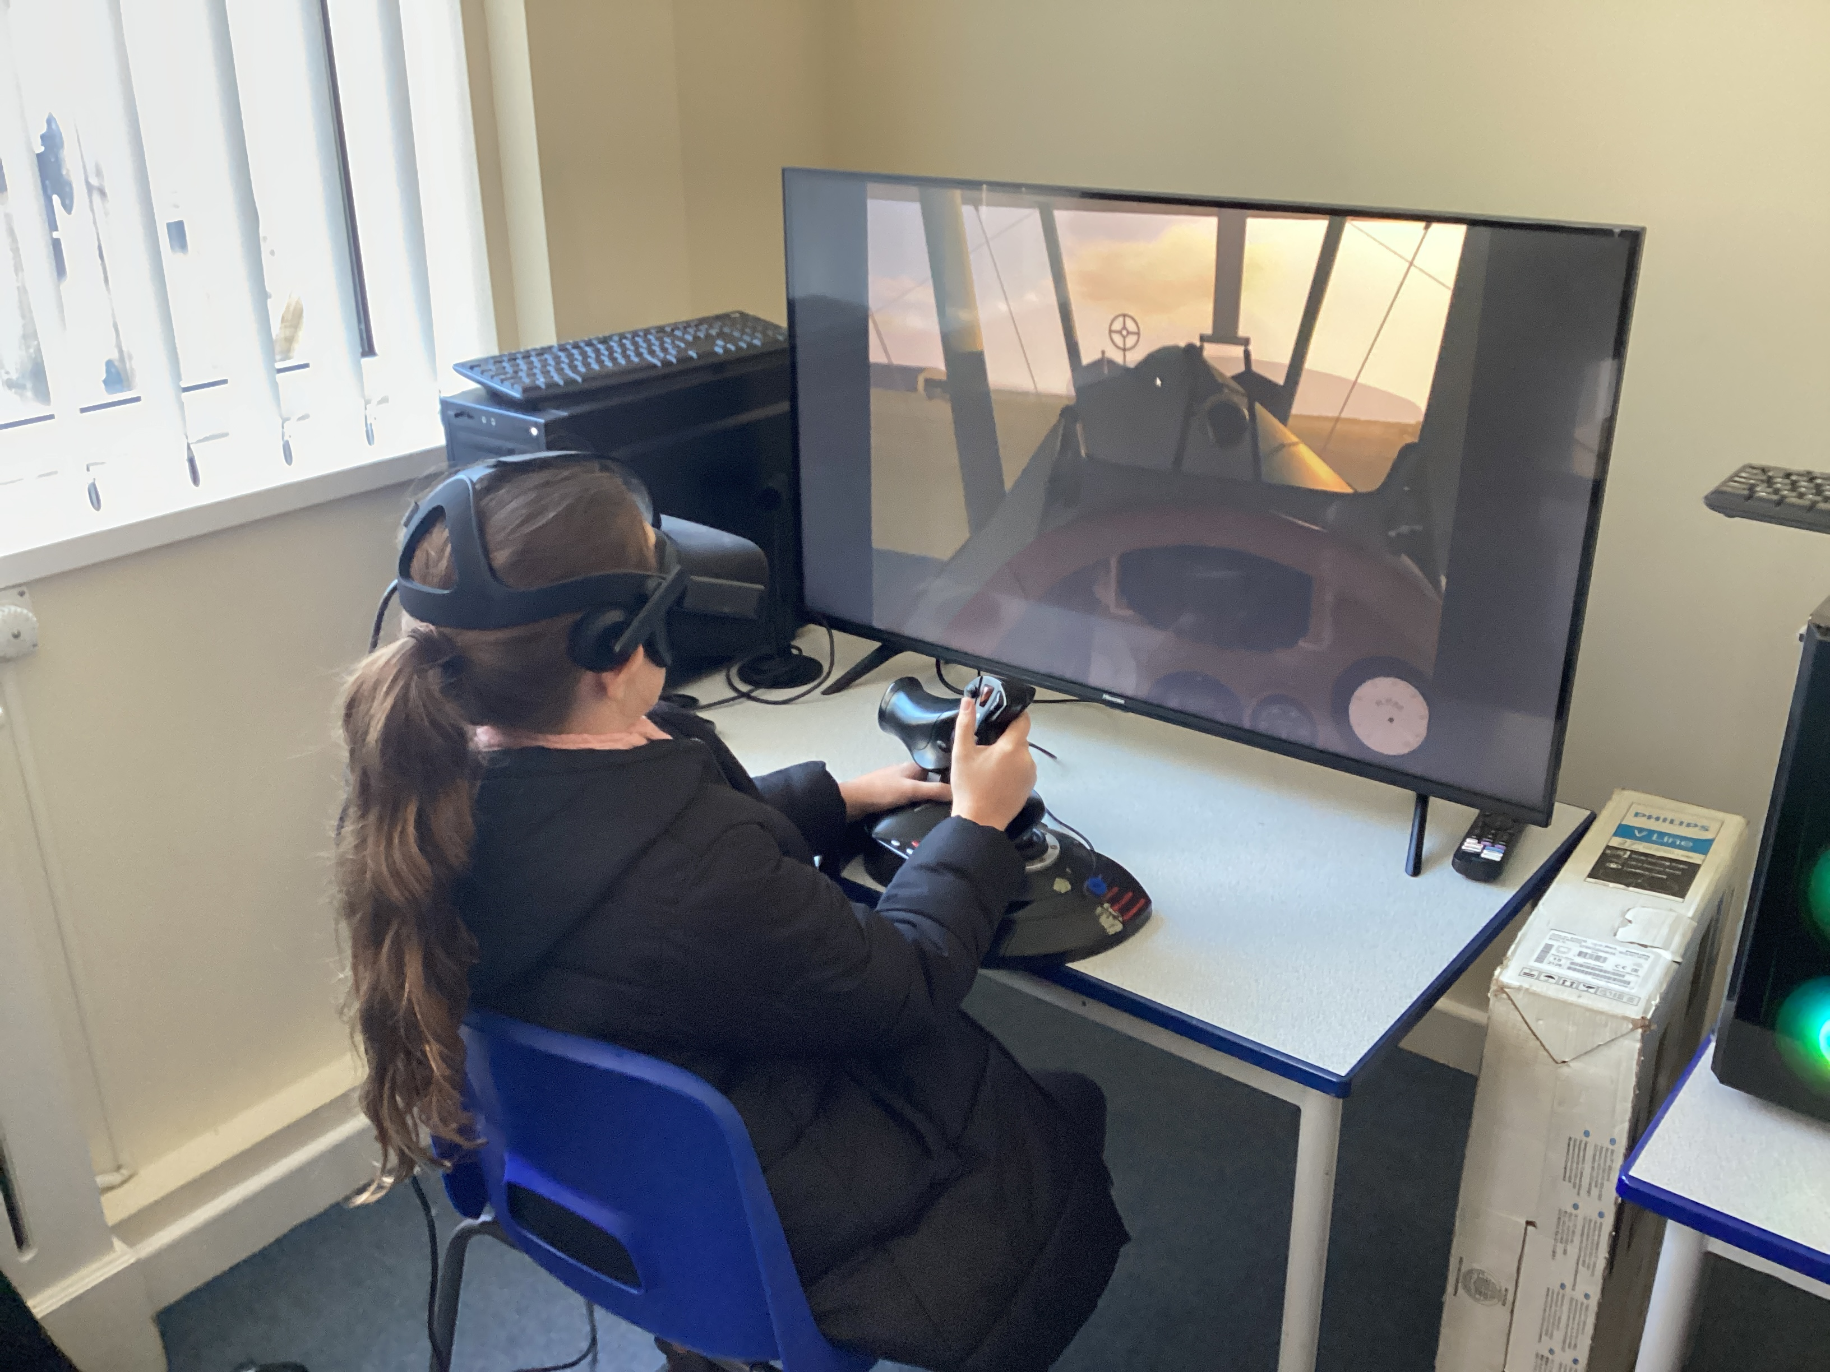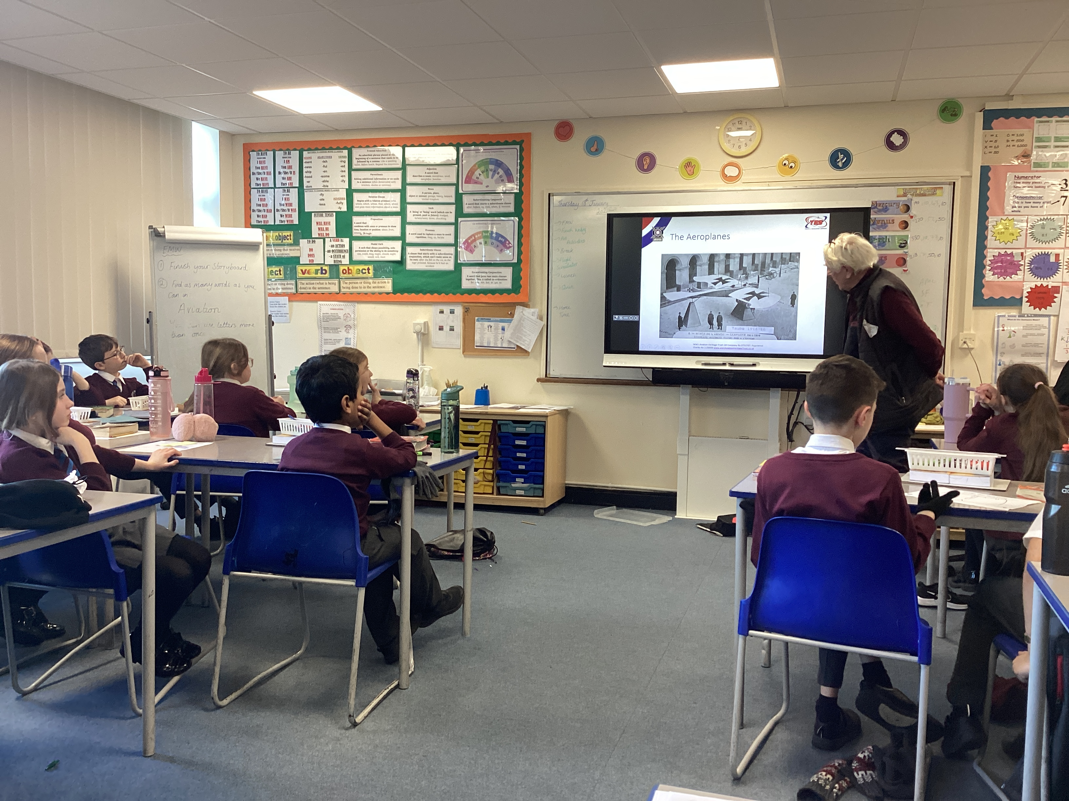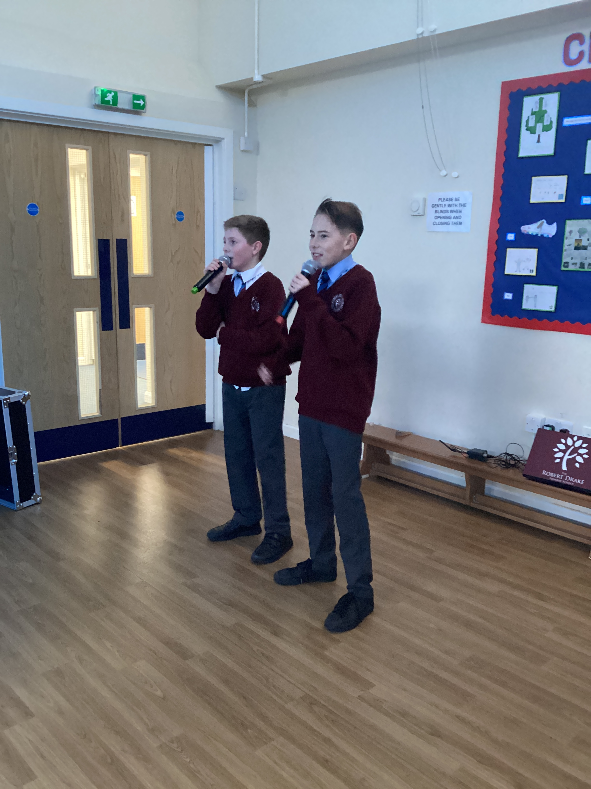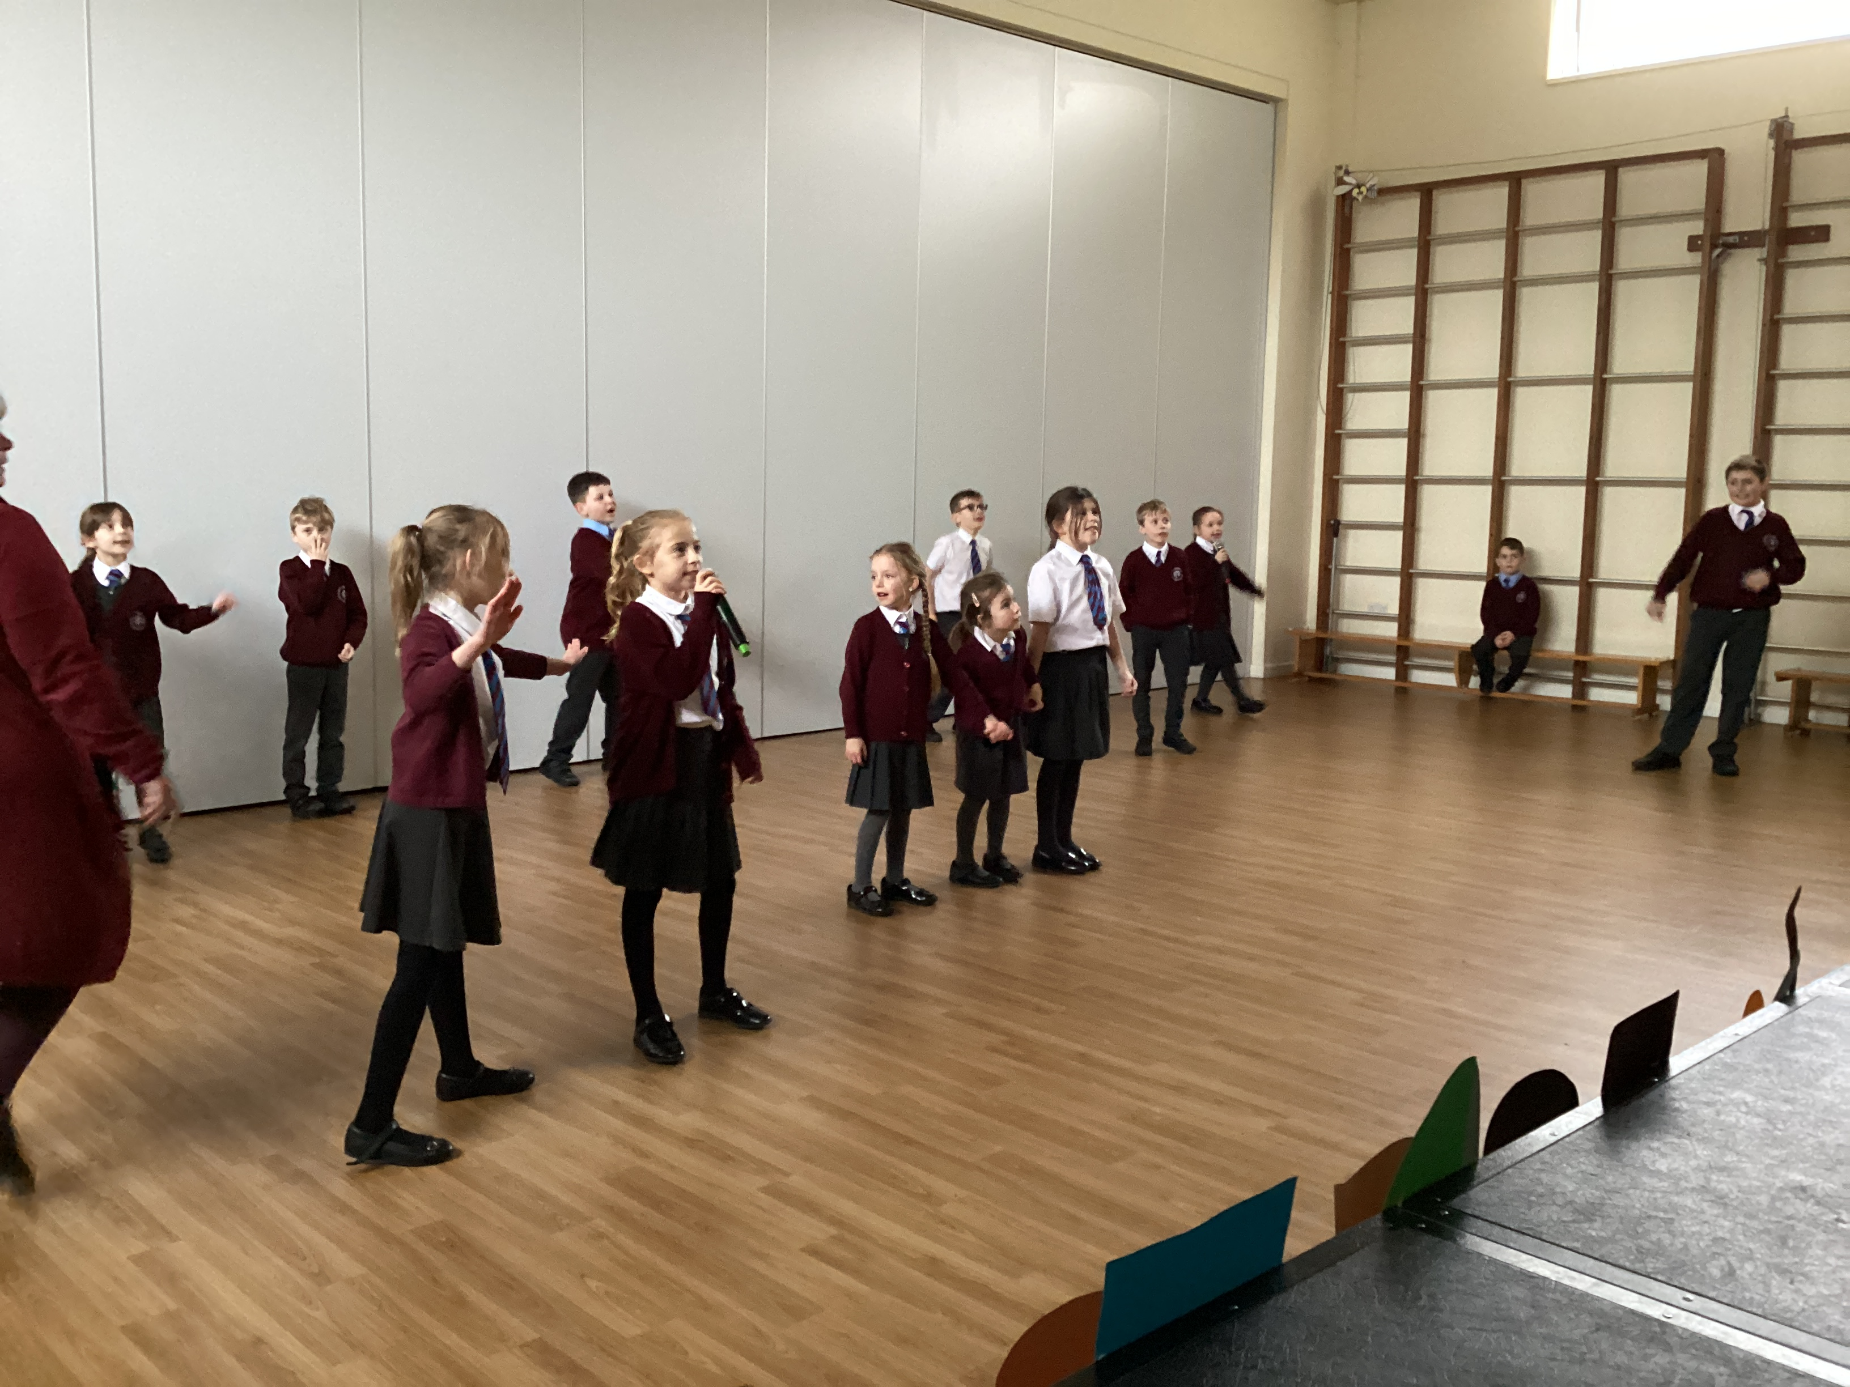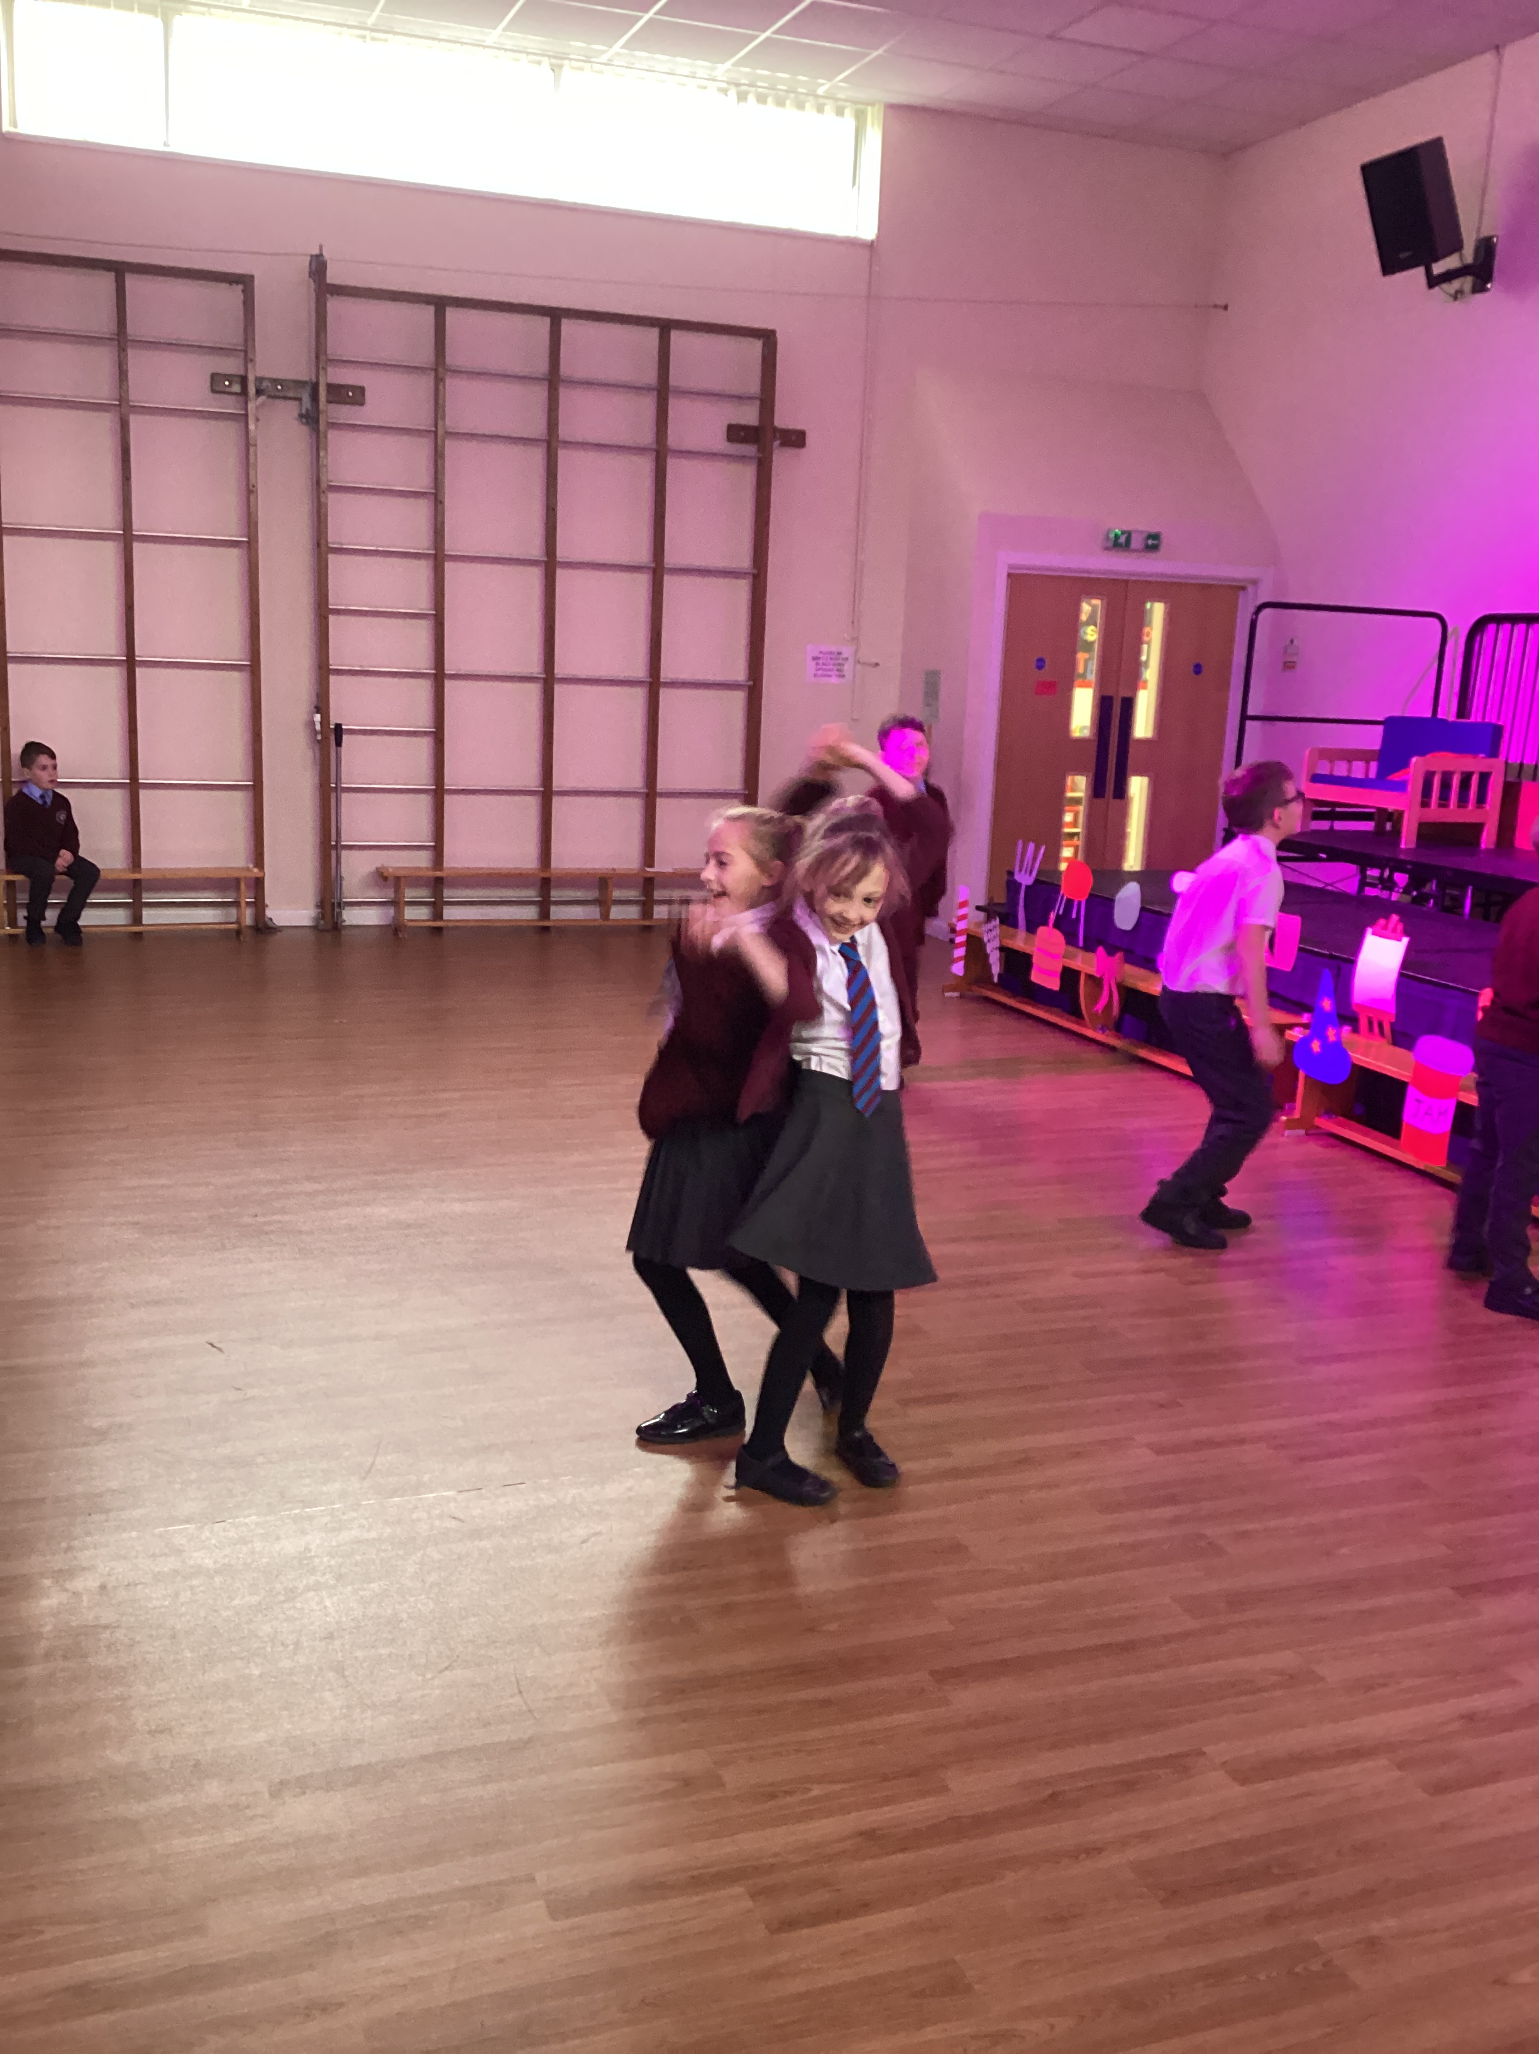
Accelerated Reader Karaoke!
Every Monday the class teachers pick a child that has read very well and consistently. At the end of term selected children are rewarded with a Karaoke party in the small hall. The first party was held on Friday and the children really enjoyed themselves! Well done to all the children who read at least 4 times a week!


Tel no: 01268 754124
Email Address:
admin@robertdrake.essex.sch.uk

Website:
www.robertdrake.co.uk

Pupil Support Officer, Mrs Green:
welfare@robertdrake.essex.sch.uk

Designated Safeguarding Leads:
Mrs Jackson – Mrs Coe
Deputy Safeguarding Leads:
Mr Smith - Mr Chaplin
Safeguarding Governor:
Mrs Foster

House colours:
Dragon | Green
Griffin | Yellow
Pegasus | Blue
Phoenix | Red

Total words read by the pupils of Robert Drake to date:
18,705,285!
Reading
The expectation is that children should read at least four times a week.
PE Days
CLASS | DAYS
EYFS | Wed and Thu
ER | Thu and Fri
NB | Mon and Fri
SG | Mon and Fri
ML | Tue and Thu
CMDH | Tue and Fri
DC | Tue and Fri
KS | Mon and Wed
DN | Tue and Fri
NP | Tue and Fri
All jewellery must be removed for PE lessons by the pupils themselves or at home before coming to school.
Menu
Details for this week’s menu can be found at:
https://robertdrake.co.uk/about-us/school-dinner-menu



Diary Dates (all dates are subject to change)
23 January: Year 3 Dance Festival
26 January; Tea and Talk with Mrs Jackson 2.30pm
5 February: Class photographs
5 February: Art Challenge week
6 February: Safer Internet Day
8 February: 9am Year 1/2 Class Assembly- Miss Bradfield
13 February: Music Mission Drumming Workshop
13 February: Year 6 NHS Height and Weight Check
14 February: Year 5/6 Badminton Festival
14 February: Fundraising- Wear Red or Pink Dress Down day
28 February: Cross Country Competition
4 & 5 March: All Years Parent Consultations
7 March: World Book Day
8 March: Year 5 Appleton Day
8 March: Year 1/2 Parent Involvement Morning
11 March: Science Week
12 March: Tea and Talk with Mrs Jackson 9am
13 March: 2.15pm Road Safety Presentation to EYFS Parents
14 March: 9am Year 1 Class Assembly - Miss Ramsey
15 March: Comic Relief
19 March: Year 5/6 Parent Involvement Morning
19 March: Infant Music Festival
20 March: KS1 trip to Braintree Museum
21 March: World Poetry day
27 March: Easter discos
March: EYFS walk to St Peter’s Church (TBC)
22 April: Year 5/6 Mini Tennis
26 April: Fundraisers Quiz Night
8 May: Character and Life Skills event Year 5/6
9 May: Tea and Talk with Mrs Jackson 9am
10 May: EYFS trip to Barleylands
13 May: SAT’s week
22 May: Year 6 Rounders Tournament
23 May: KS1 trip to Sealife Adventure
3-21 June: Year 4 Multiplication Tables Check
13 June: Junior Music Festival, Cliffs Pavilion
14 June: Year 3/4 Trip to Museum of Power
17 – 21 June: Year 6 Residential trip to Stubbers
19 June: KS1 Summer games - Deanes
21 June: Year 3/4 Parent Involvement morning
24 June: Tea and Talk with Mrs Jackson 2.30pm
24 – 28 June: Book Fair
25 – 26 :- Year 6 Secondary School Transition days
26 June – 9am Year 5 Class Assembly
27 June: Sports Day
28 June: Year 5 Danbury Trip
2 July: Railway Children production to school
6 July: Summer Fun Day
11 July: Reports and Open Evening
15 July: Leavers’ Disco
23 July, 9am Leavers’ Assembly


Geraldine the Giraffe
Well done to Year 6 in Mr Newton’s Class for attaining 100% attendance in week 2! Amazing!

Geraldine will be with Mr Newton’s class again this week!

Well done all pupils that are in school every day and on time!
Attendance

National expectation for regular attendance is that children must be in school every day. Every second counts and we must work together to improve attendance and punctuality.

Class Week 2 Week 3
Miss Baldwin | 98.6 |  | 93.8
Miss Simpkin | 94.3 |  | 83.0
Miss Ramsey | 91.0 |  | 89.0
Miss Bradfield | 96.0 |  | 97.7
Miss Glover | 97.6 |  | 97.2
Miss Leckerman | 94.3 |  | 98.0
Mrs Malyan/Mrs Herbert | 98.3 |  | 97.2
Mr Chaplin | 99.0 |  | 96.1
Mr Smith | 96.0 |  | 95.3
Mr Newton | 100 |  | 99.7
Mrs Parrag | 94.0 |  | 95.7

Term Dates: 
Non-pupil day: 16 February
Half term: 19 to 23 February
Easter: 29 March to 12 April
Half term: 27 May to 7 June
Non pupil day: 12 July
Summer: from 24 July

Dates for Class Assemblies, all start 9 am:
Miss Bradfield: Thursday 8 February
Miss Ramsey: Thursday 14 March
Year 5: Wednesday 26 June
Year 6: Tuesday 23 July
Dates for Parent Consultations:
All years: 4 and 5 March
All years: 11 July – open evening

Please note that all dates are subject to change Please note all dates are subject to change

Achievements
Last week and this week we are proud to celebrate the following who received Achievement awards: 
Miss Ramsey: Millie & Ava Mrs Malyan/Mrs Herbert: Lily & Sophie Miss Baldwin; Harley & Eddie
Miss Bradfield: Oscar & Isaac Mr Chaplin: Dempsey & Alice & Rosie Miss Simpkin: Ava & Poppy
Miss Glover: Bobby & Albie Mr Smith: Franky & Scarlett Mr Newton: Scarlett & Ibrahim
Miss Leckerman: Tabitha & Rebecca Mrs Parrag: Mia M & Belle

A special mention to Scarlett in Mrs Malyan & Mrs Herbert’s class who auditioned for Bugsy Malone at the Towngate Theatre and has been accepted! Fantastic news!

Well done all, but remember that all our pupils are stars!

If your child has any achievements outside of school, please do ask them to share them with us so that we can recognise them and their accomplishments.
E-Safety
E-Safety information from the Robert Drake website:
https://robertdrake.co.uk/about-us/e-safety
NSPCC website with useful information on online safety:
https://www.nspcc.org.uk/keeping-children-safe/online-safety/


Tea and Talk Sessions All are welcome to the ‘Tea and Talk’ sessions with the Co-Headteacher Mrs Jackson. Sessions are as follows:
Friday 26 January, 2.30 pm Thursday 9 May, 9 am
Tuesday 12 March, 9 am Monday 24 June, 2.30 pm

Nut Free School/Packed Lunches    The Robert Drake Primary is NUT FREE. We have pupils with severe air borne nut allergies and to safeguard our children all visitors must refrain from eating nuts and nut based products for at least 6 hours before visiting the school.    - All packed lunches should be healthy and nut free. |   Pre-Loved Uniform Shop  Each item is priced at £1.00; all payments to be made via ParentPay.  Purchases can be made as follows:  - The pre-loved uniform shop is open in the small hall at 3.15 pm on the last Friday of each month  - Parents/carers can email into admin@robertdrake.essex.sch.uk with details of the items they require, ie, item required, size, gender, etc  - Parents/carers can enquire at the school office.
Water Bottles    It is important that all pupils bring in a water bottle each day filled with plain water; it can be filled up at water stations during the day. This helps the children to remain hydrated and helps them to focus on their learning - ‘knowing more and remembering more’.  The water bottles should have a sports cap to avoid spills. |   Uniform  All pupils should adhere to the school’s uniform policy. The policy can be found on the school’s website at  https://robertdrake.co.uk/about-us/school-uniform  Please ensure that all items of uniform are clearly labelled.  A reminder that if hair can be tied up, then it should be.
Safeguarding Information for Parents and Carers  https://www.nspcc.org.uk/what-is-child-abuse/  www.nspcc.org.uk  https://www.nspcc.org.uk/keeping-children-safe/support-for-parents/  Parenting tips and support for dealing with difficult situations. | School Premises/Parking    Please note that dogs should not be brought on to the school grounds at any time, unless they are assistance dogs for the blind; this includes whether on a lead or being carried.    We would also request that all parents/carers respect the school’s neighbours and only park legally and with consideration for others. For safety reasons, at no time of the day should cars pull into the school’s driveway.
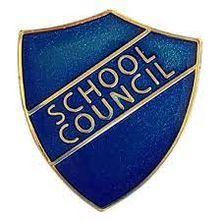  School Council  School Councillors are voted for by the children during the school year. Two per class.  The councillors meet regularly and discuss and decide upon events and changes they would like to put forward, ie, menu items, fundraising days, sport played in school, to give some examples.  The next council meeting will be taking place in the New Year. | Clubs    There are several clubs that take place at the school every week; full details are available on the school’s website  https://robertdrake.co.uk/clubs or from the office.  Taking into account parents’ views at the Tea and Talk sessions, the school has introduced new clubs and is trying to provide a broad spectrum of clubs available, and these include, among others, drama, football, karate, netball, computing, music, fencing, crafting, Bricks4Kidz, etc.
Friends of Robert Drake  The school has an active fundraising group. They are always looking for volunteers and hold regular meetings at the school; everyone is welcome.  They can be contacted through their Facebook page:    ’Friends of Robert Drake School’  Please check out their site for full details of forthcoming fundraising events. | Pupil Premium / Free School Meals  You may register your child for Free School Meals if you receive a range of benefits with qualifying conditions such as Income Support, Income-based Jobseeker's Allowance, Income-related Employment and Support Allowance and Child Tax Credit, Working Tax Credit run-on, and Universal Credit.  If you think you may be eligible:  If your child is in Year 2 or below, please call the School Office and we will send you through a form to complete.  If your child is in Years 3—6, Essex County Council has an online application form on their website: https://www.essex.gov.uk/free-school-meals
Is my child too ill for school?
It can be tricky deciding if you child is too ill for school. Please find below a link to the NHS website which provides guidance on common childhood illnesses and advice. Is my child too ill for school? A parent’s guide to keeping kids healthy this school term

The Governing Body of The Robert Drake Primary School is committed to safeguarding and promoting the welfare of
children and expects all staff and volunteers to share this commitment

